**Stephen Edward Ng PDA Evidence**

|  |  |
| --- | --- |
|  |  |

**Array**

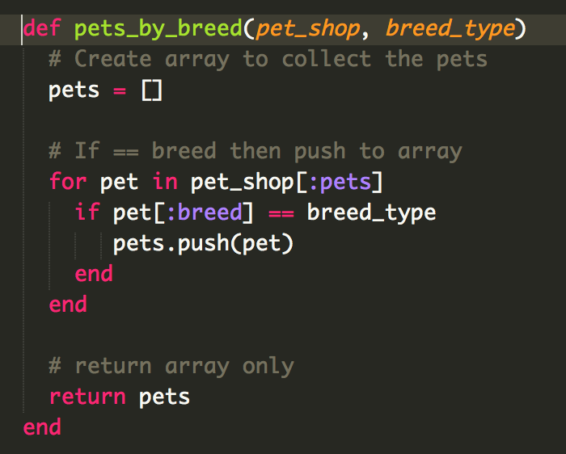

Test using the array

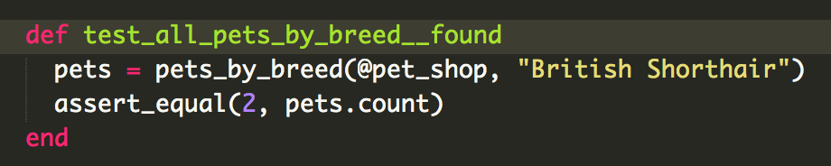

Result of successful test

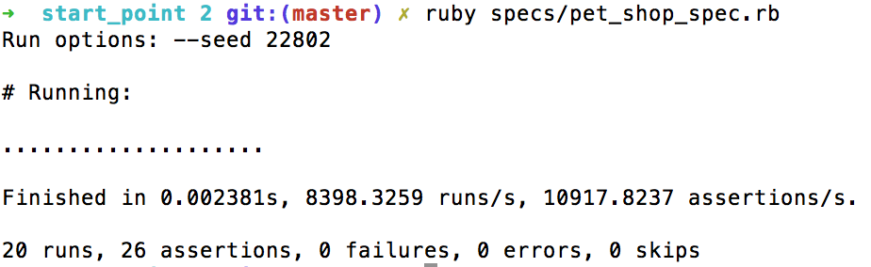

**Hashes**

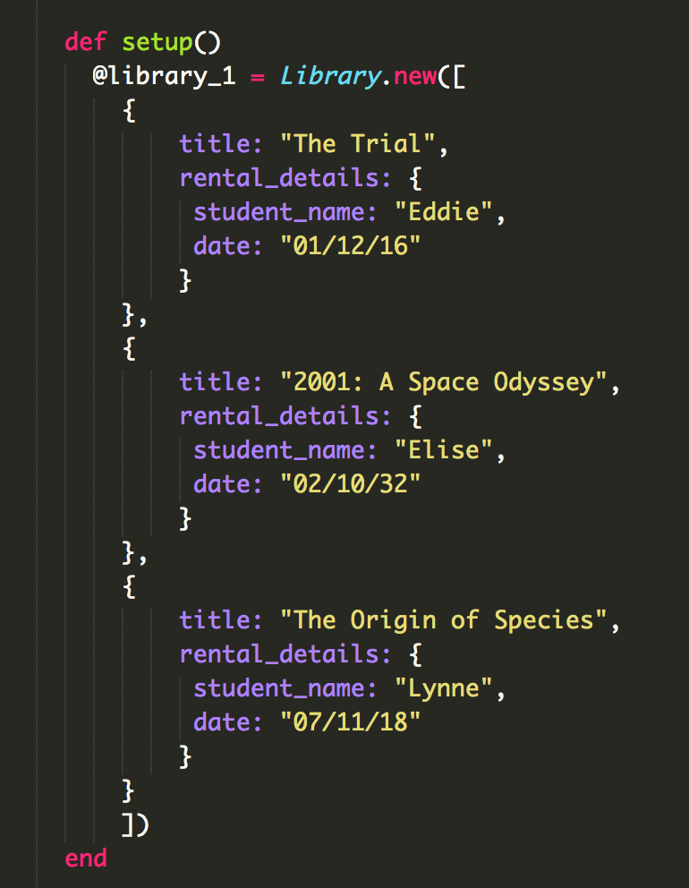

Search through library array for book title then return hash element

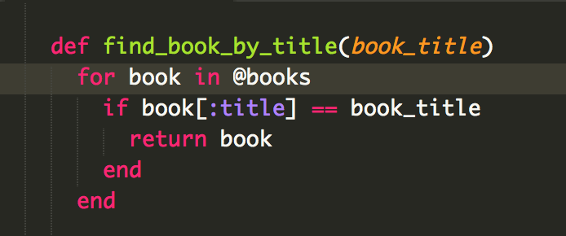

The result of the function running

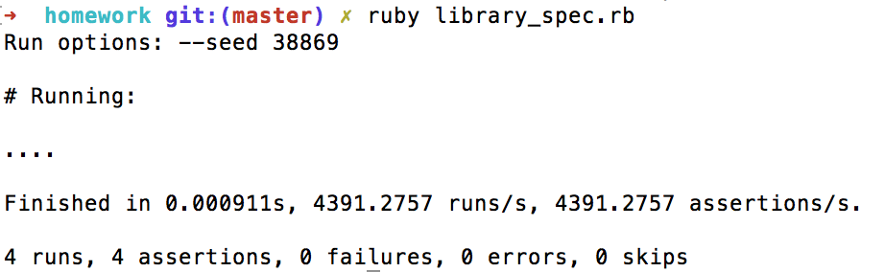

**Search data**

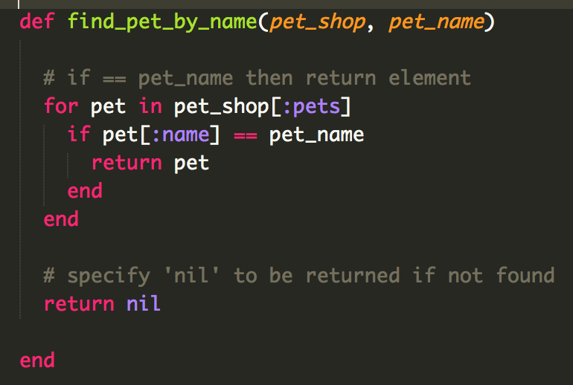

Search for a book by title and return the rental details

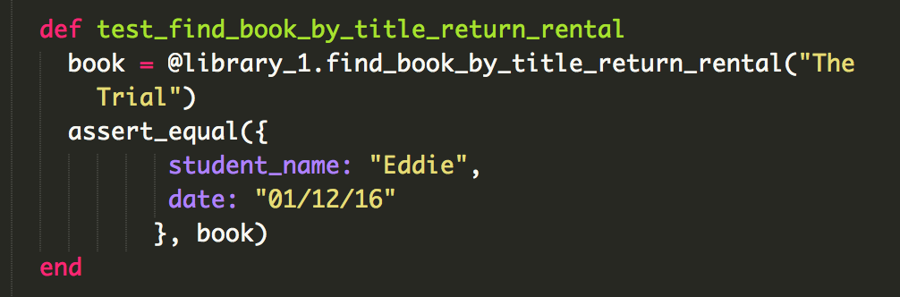

Test

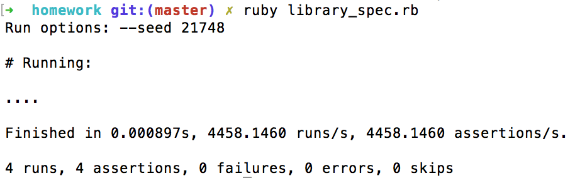

Searching database

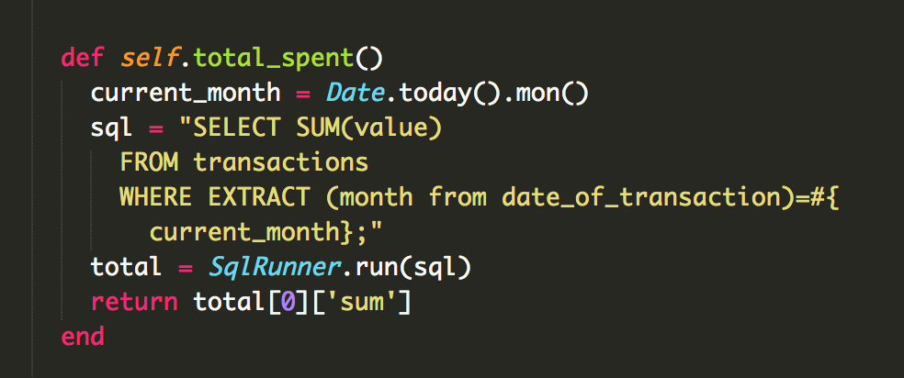

Result



Sorting data by month

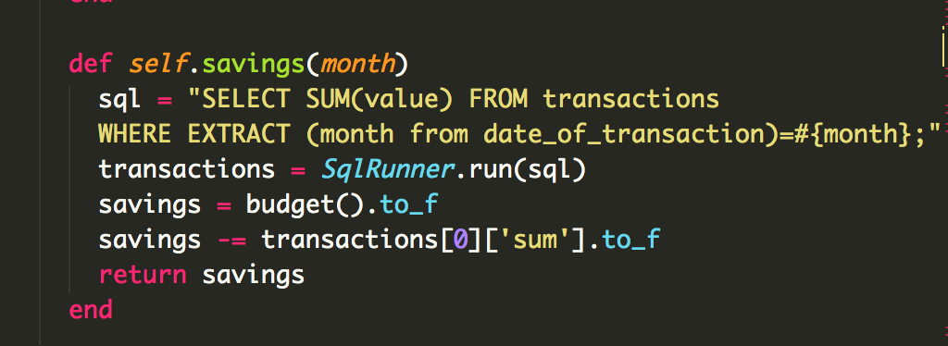

Result

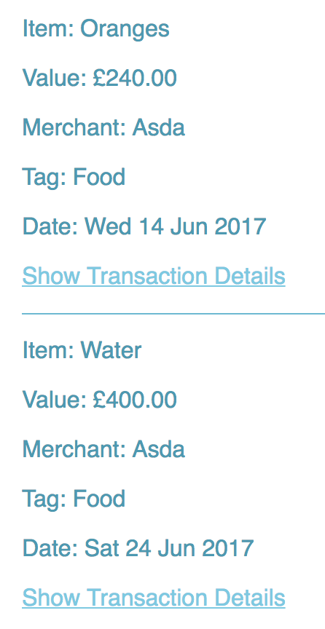

**Polymorphism**



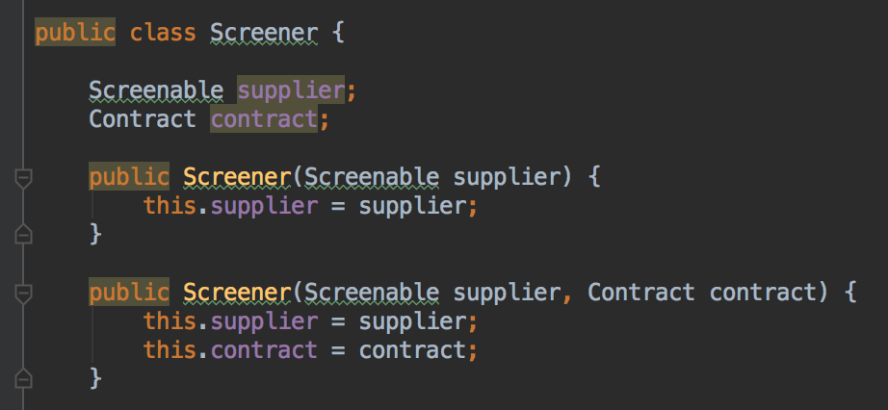

Pass in a supplier as a Screenable rather than a Supplier

**Inheritance Diagram**

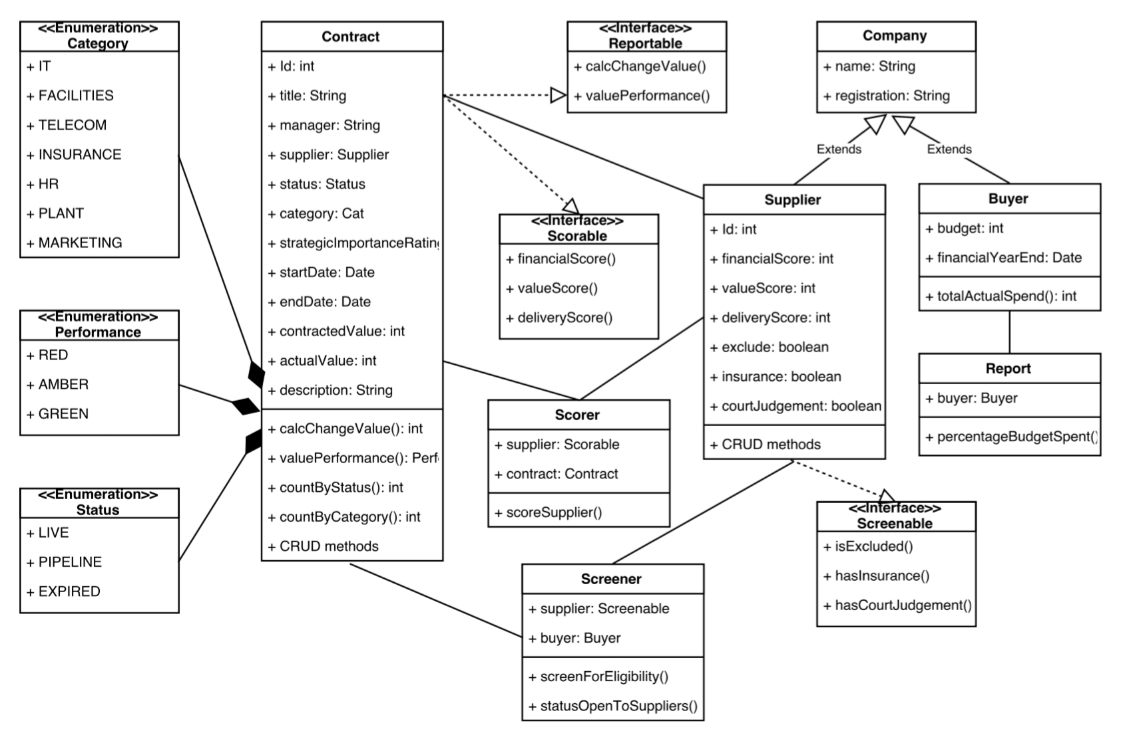

**Encapsulation**

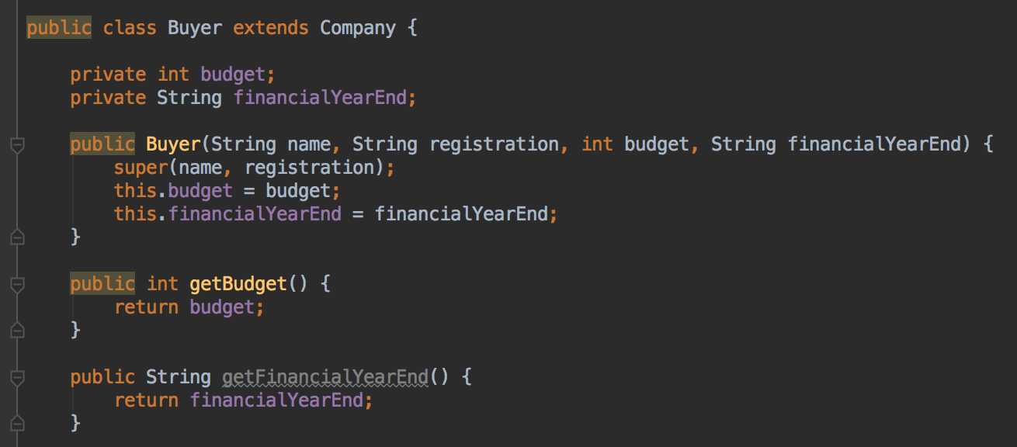

budget and financialYearEnd are declared as private and getters are used to access them.

**Inheritance in a Program**

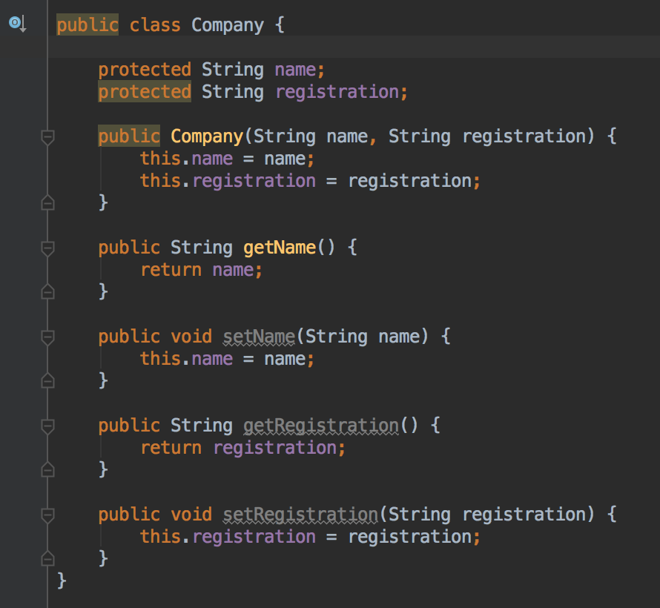

Supplier inherits name and registration from Company

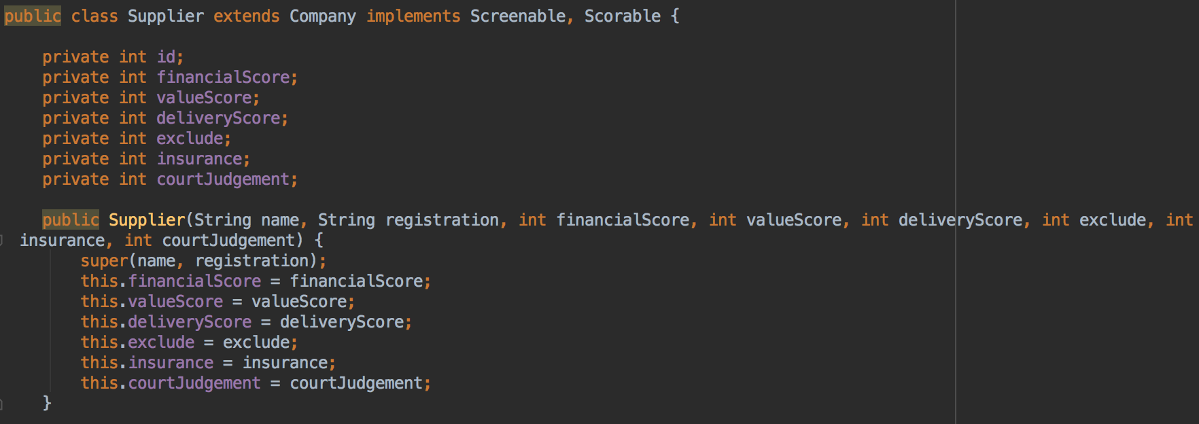

And is used to access SQL database

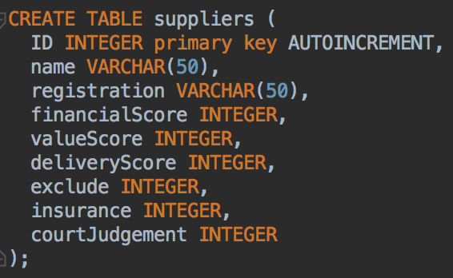

Method that accesses information from both the superclass and subclass



**Screenshot of one of my projects where I worked alone**

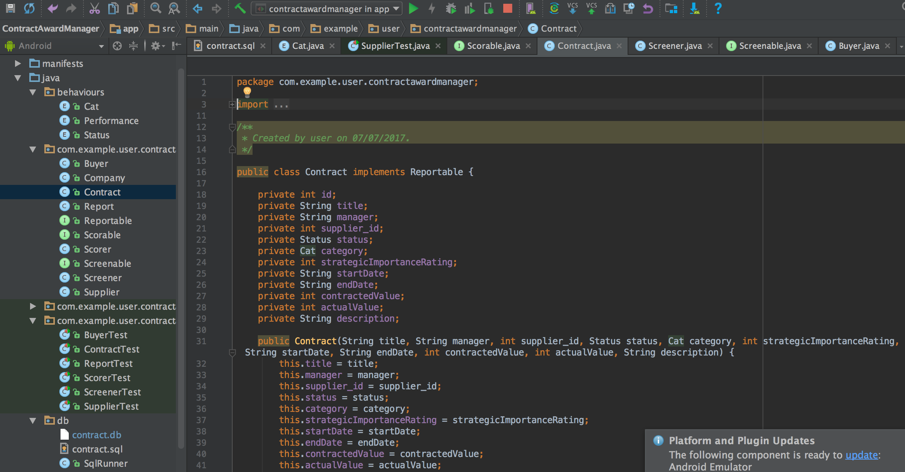

GitHub link

git@github.com:stephenedwardng/ContractAwardManager.git

Planning evidence

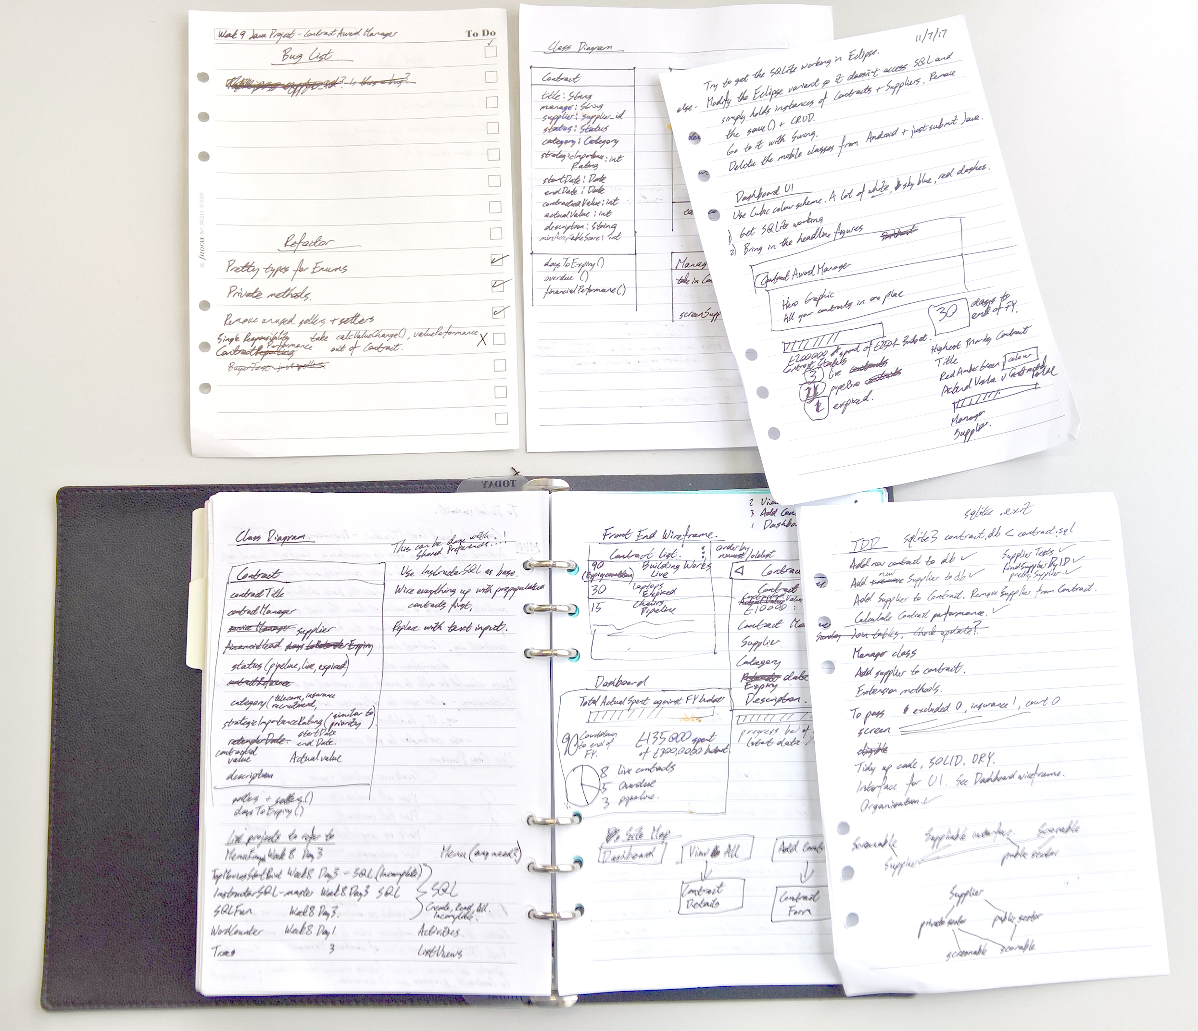

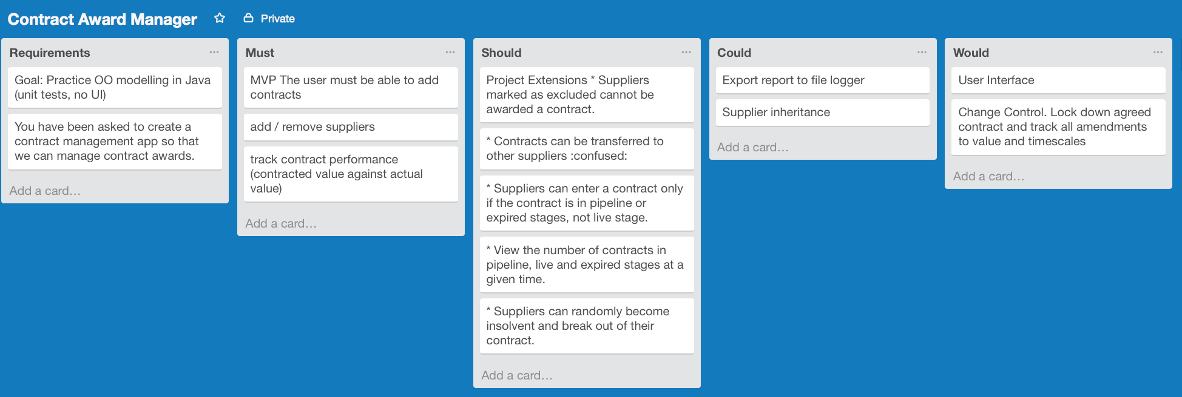

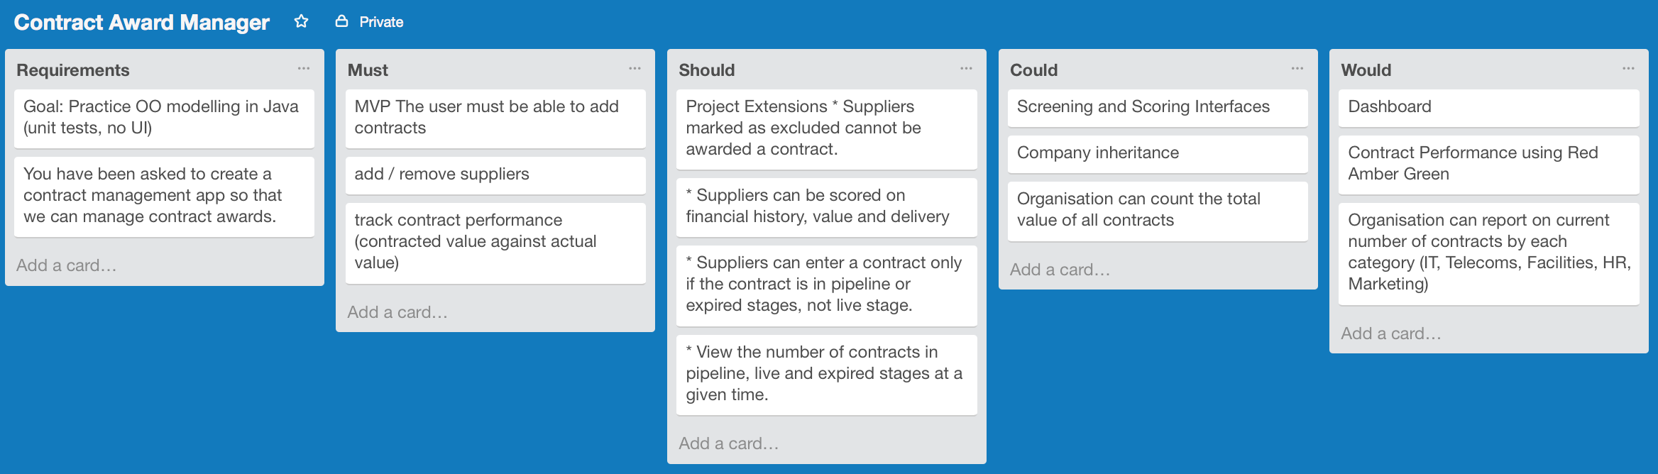

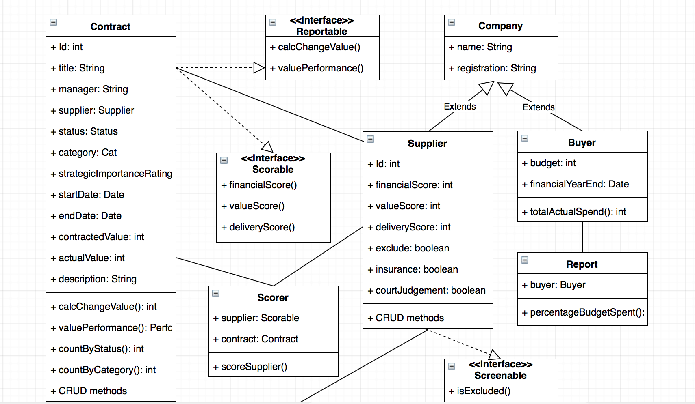



Test

Function

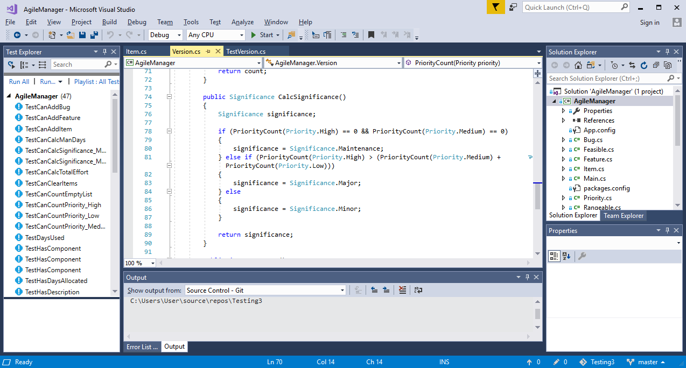

Unit test

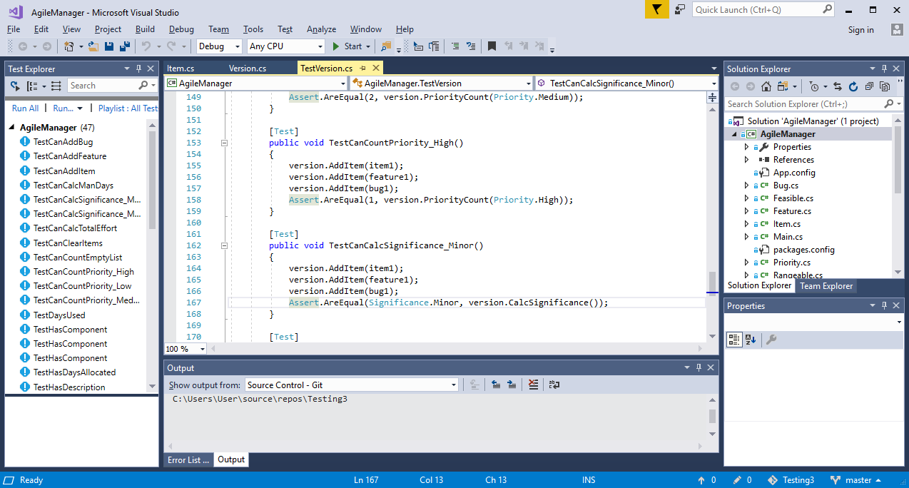

Test failing for CanCalcSignificance (Major and Minor conditions). Screenshot shows incorrect less than operator on line 81

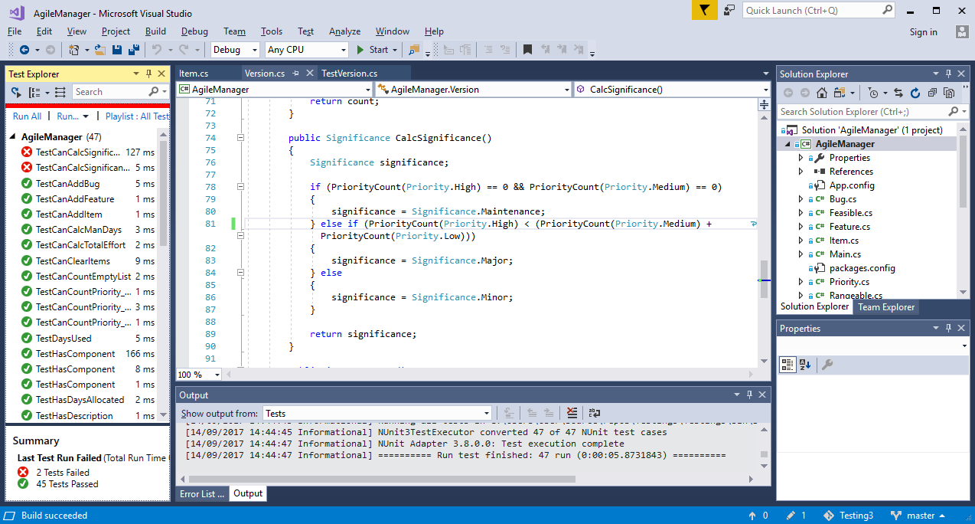

Operator corrected to Greater Than



Test Passing for CanCalcSignificance

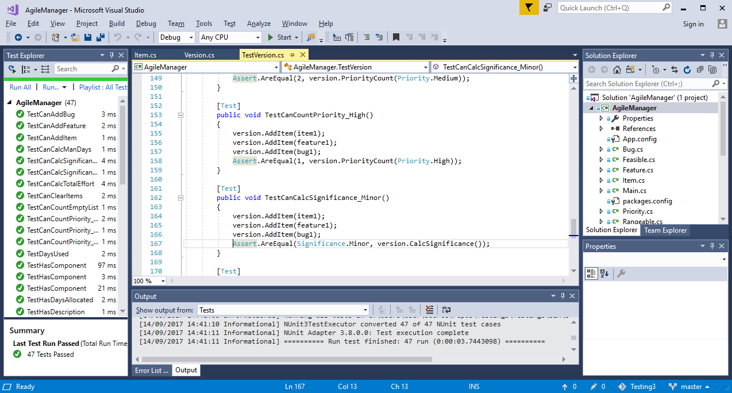

API

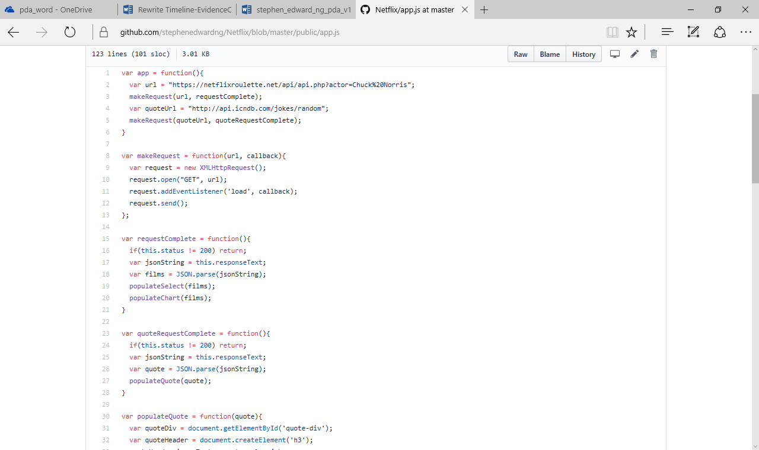

API in running program

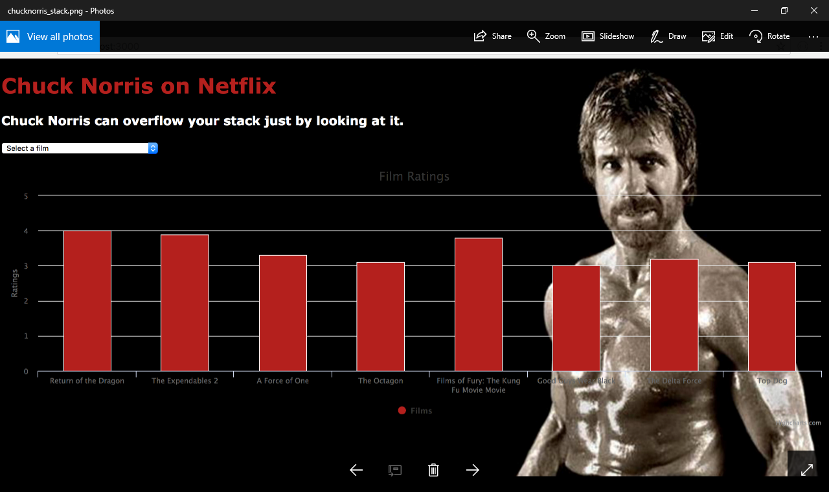

Group project commits- contribution page

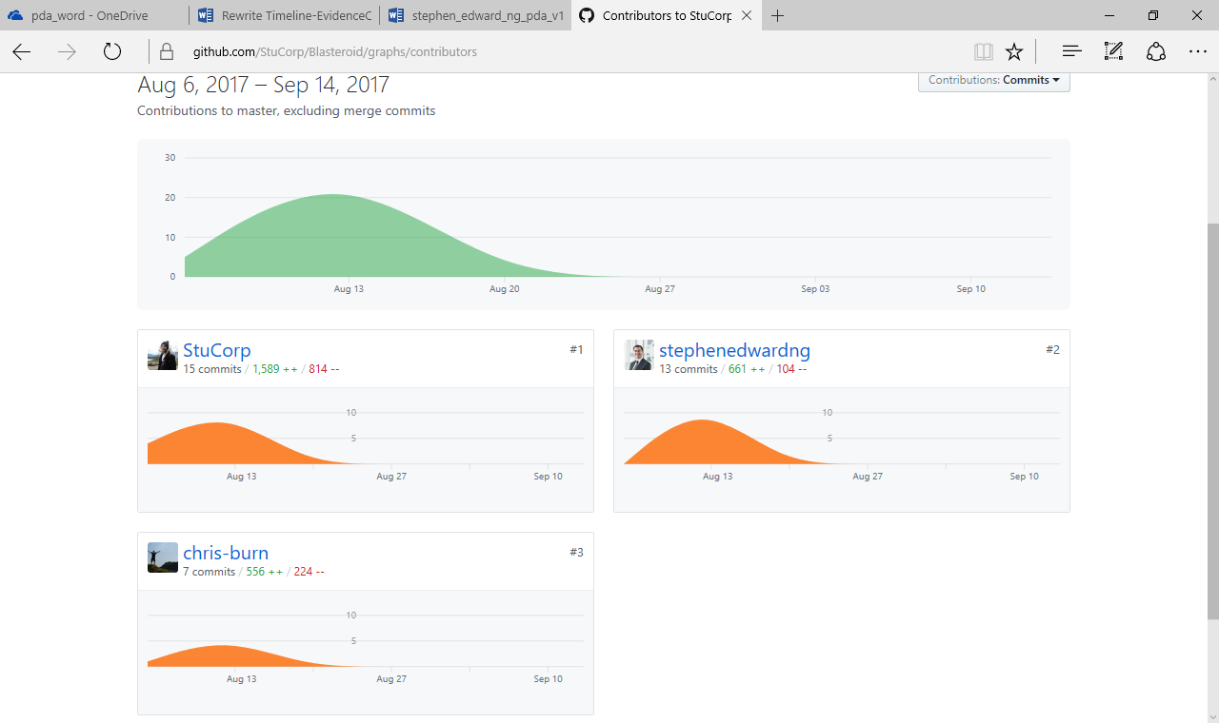

Group project brief

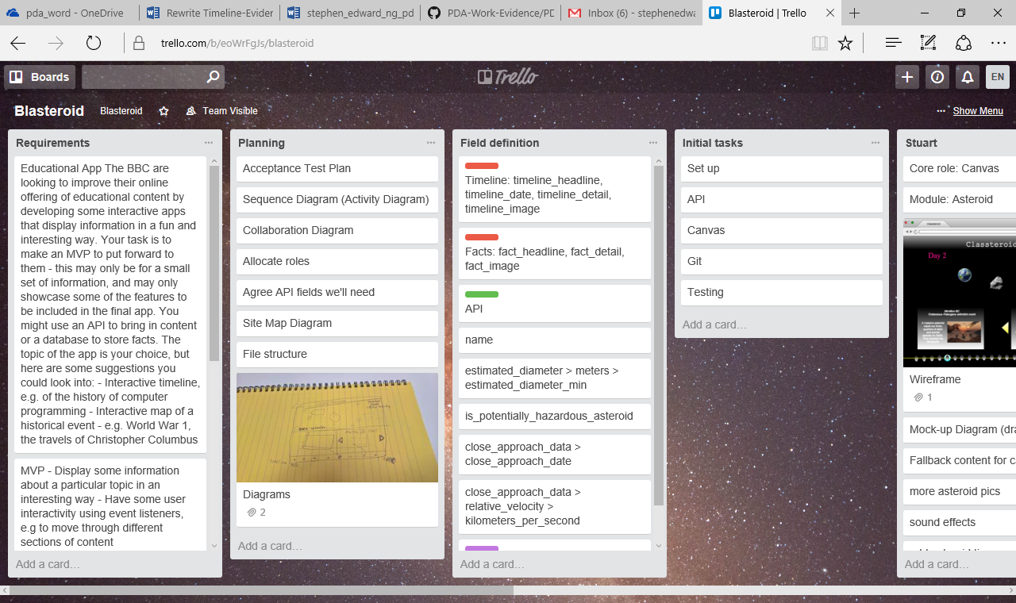

Trello Moscow board



Acceptance Criteria and Test Plan

|  |  |  |
| --- | --- | --- |
| User should be able to | Test | Outcome |
| View significance of the sprint | Automatically calculate priority and assign significance rating | Major. Pass |
| Add a backlog item | Increment backlog count | Pass |

Algorithms

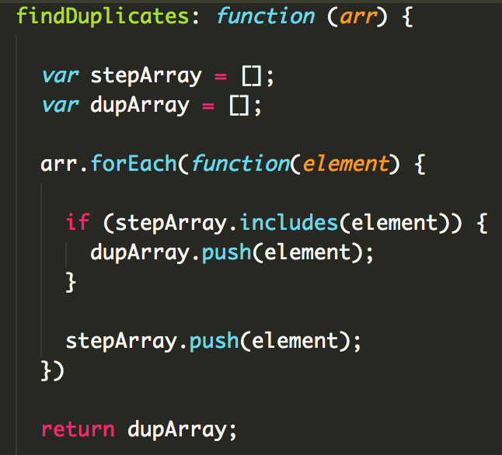

Function to find duplicates in an array and return a new array of the duplicates.

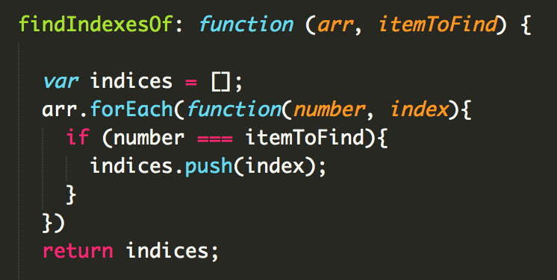

Function to find the indices of elements in an array and return new array of indices.